Account Opening Interface Specification Low Level Design Document

**EIDIKOSYSTEMS INTEGRATORS**



Version: 1.0

Release Date:11-08-2020

|  |  |  |
| --- | --- | --- |
| Prepared By | Reviewed By | Approved By |
| EIDIKO |  |  |

Document Classification: CONFIDENTIAL

Contents

1 Introduction 5

1.1 General Description 5

2 Purpose 5

3 Scope 5

3.1 In Scope 5

4 Channels Involved 5

5 Interface Dependencies 6

5.1 External Dependencies 6

5.2 Internal Dependencies 6

6 Business Process Summary 7

6.1 Process Overview 7

Figure: 1 Process flow Approach for Account Opening. 8

6.1.1 Account Opening Steps 8

7 IIB Implementation Process Flow 9

7.1 Account Opening Successful Request Response Flow 9

7.1.1 Process Diagram 9

7.1.2 Process Flow Steps 9

7.2 Retry Process workflow 11

7.2.1 HTTP Process Flow Diagram 11

7.2.2 Process Flow steps 11

7.2.3 TCP Process Flow Diagram 12

7.2.4 Process Flow steps 12

7.3 Raw_Audit Process Flow: 13

7.3.1 Process Flow Diagram: 13

7.3.2 Process Flow Steps: 13

7.4 HTTP Router Process Flow 14

7.4.1 Incoming Router Process Flow Diagram: 14

7.4.2 Process Flow Steps: 14

7.4.3 STEWARDBANK ESB TRANSACTION DETAILS 15

7.4.4 Outgoing Router Process Flow Diagram 16

7.4.5 Process Flow Steps: 16

7.5 Error_Audit Process Flow 17

7.5.1 Process Flow Diagram: 17

7.5.2 Process Flow Steps: 18

8 Interface Definitions 18

8.1 Request Message Definition 18

8.1.1 Channel Request Message Structure /Schema 18

8.1.2 Channel Request Message Details 18

8.1.3 Channel Sample Source Messages 21

8.1.4 T24 Request Message Structure /Schema 23

8.1.5 T24 Response Message Details 23

8.1.6 T24 Sample Source Messages 23

8.2 Response Message Definition 24

8.2.1 Channel Response Message Structure/Schema 24

8.2.2 Channel Response Message Details 24

8.2.3 Channel Sample Response Messages 26

8.2.4 Channel Error Response Message 31

8.2.5 Data Base Error Response Codes 31

9 Logging Mechanism 32

9.1 Insert into RAW_AUDIT_TABLE 32

9.2 Insert into ERROR_AUDIT_TABLE 33

9.3 File Based Logging 35

9.3.1 Log4j 35

**Approval**

|  |  |  |  |  |
| --- | --- | --- | --- | --- |
| Project Role | Approver | Company | E-mail | Sign-Off Date |
|  |  | Eidiko |  |  |
|  |  |  |  |  |
|  |  |  |  |  |
|  |  |  |  |  |
|  |  |  |  |  |
|  |  |  |  |  |
|  |  |  |  |  |

**Revision History**

|  |  |  |  |
| --- | --- | --- | --- |
| Date | Description | Version | Author |
|  |  |  |  |
|  |  |  |  |
|  |  |  |  |
|  |  |  |  |
|  |  |  |  |
|  |  |  |  |

# Introduction

## General Description

This Interface Design document outlines the integration requirements for the Account Opening ***(Request and Response)***interface used as banking operations. It summarizes the business processes, which use this interface. It also covers error handling and exception scenarios.

# Purpose

The purpose of this document is to capture events that trigger the interface, main steps within the interface and the integration architecture. This document is intended for use by the developers of the applications identified, the integration development team, and by the test organizations responsible for the testing of these applications.

# Scope

## In Scope

This document focuseson outlining the interface design for the Account Opening ***(Request and Response)***interface. Central to this document are the following:

* Overview of the business process that drives the need for the interface
* Proposed integration approach
* Trigger events and business dependencies on this interface
* Sequence /Flow Chart diagram of the interface
* Error handling and exception scenarios
* Validation and backup requirements

# Channels Involved

The following table lists Currency Converter channels

|  |  |
| --- | --- |
| **Item #** | **Channel Name** |
| 1 | USSD |

# Interface Dependencies

## External Dependencies

The following table lists interface specific External requirements.

|  |  |
| --- | --- |
| **Item #** | **External Requirements** |
| 1 | Steward Database – (SQLDB) |
| 2 | Core Banking System(Temenos-T24) |
| 3 | Postilion System |

## Internal Dependencies

The following table lists interface specific internal requirements.

|  |  |
| --- | --- |
| **Item #** | **Internal Requirements** |
| 1 | HTTP Router Interface (Gateway) - StewardBankHttpRoutersApp |
| 2 | HTTP Retry Interface (Subflow) - StewardBankHttpRetryCall |
| 3 | DB Logging App (Audit Logging) |
| 4 | StewardBankCommonEsql (Shared Library) |

# Business Process Summary

## Process Overview

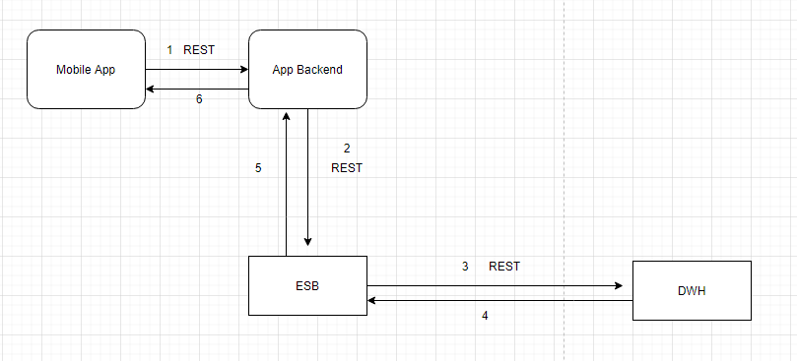

### Figure: 1 Process flow Approach for KYC.

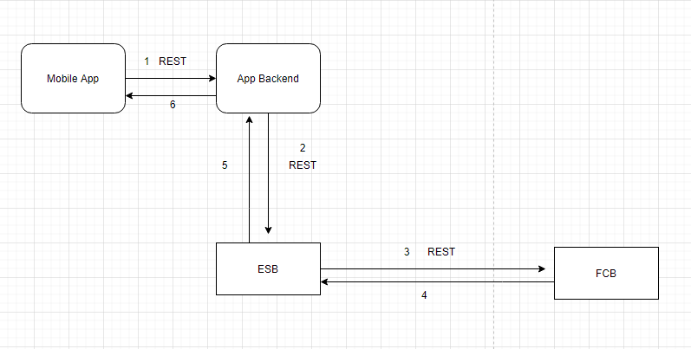

### Figure: 2 Process flow Approach for Check Customer Record.

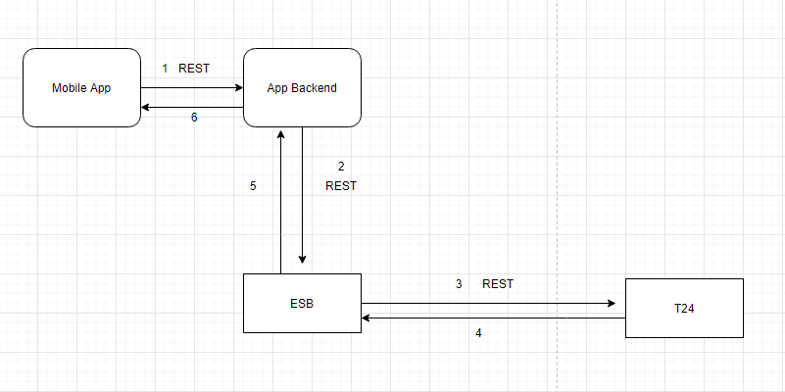

### Figure: 3 Process flow Approach for Check Customer Existence.



### Figure: 4 Process flow Approach for Create Customer Profile.



### Figure: 5 Process flow Approach for Create Account.



### Figure: 6 Process flow Approach for Create Prospect Customer.

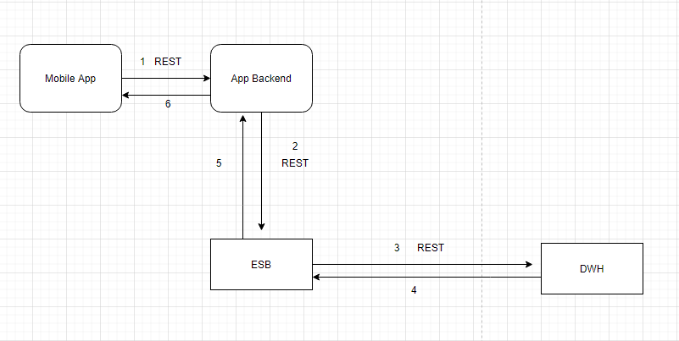

### Figure: 7 Process flow Approach for Update Customer Record.

## Account Opening Steps

|  |  |
| --- | --- |
| **S. No** | **Activities** |
| 1 | Account Opening is a step by step process. |
| 2 | ESB receives request from App Backend (channel) for all the steps one after the other. |
| 3 | The very first step is to Know the customer (KYC) by checking the customer information in Steward’s data warehouse (DWH). The response from DWH will be send back to channel. |
| 4 | Second step is to find Credit rating of the customer with FCB, If customer has bad credit rating then will log the customer record. Otherwise will go for the next step. |
| 5 | If customer has good credit rating then, will check the customer record with core banking system i.e T24 to fetch customer information. |
| 6 | The next step is to create customer profile, ESB frames request to T24 to create customer profile. |
| 7 | After creating profile of the customer, ESB frames request to create customer Account to T24. |
|  | Finally ESB will update customer record to DWH if the process was successful. |

# IIB Implementation Process Flow

## Account Opening Successful Request Response Flow

### Account Opening Router Process Diagram

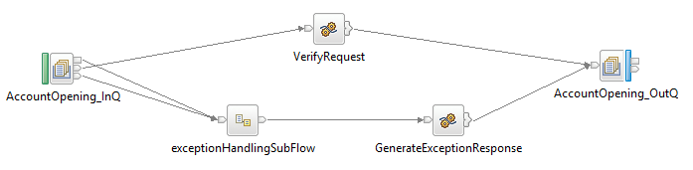

### Know your Customer Process Diagram

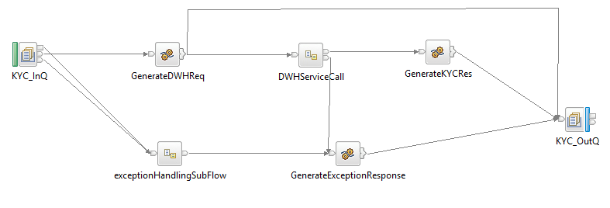

### Search HITs on Customer Process Diagram

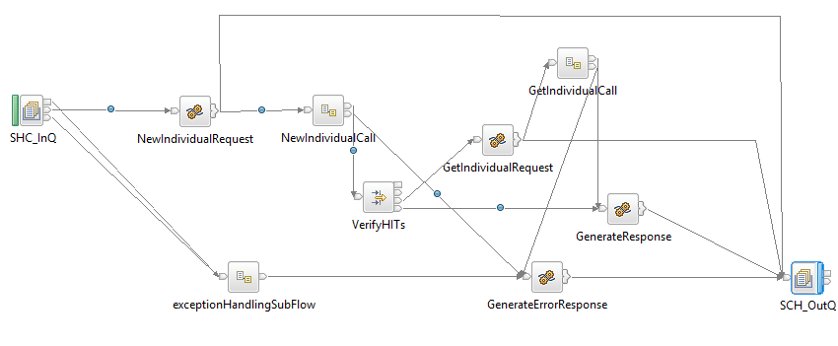

### Is Customer Exists Process Diagram

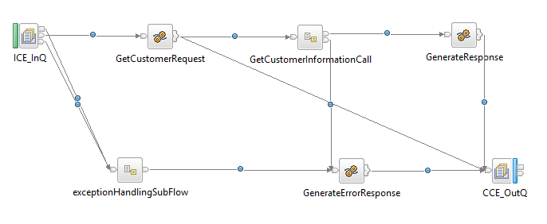

### Create Customer Profile Process Diagram

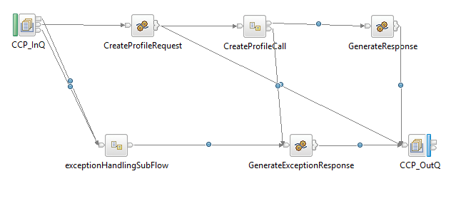

### Create Customer Account Process Diagram

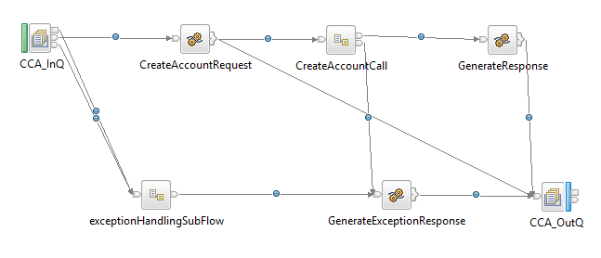

### Update Customer Record Process Diagram

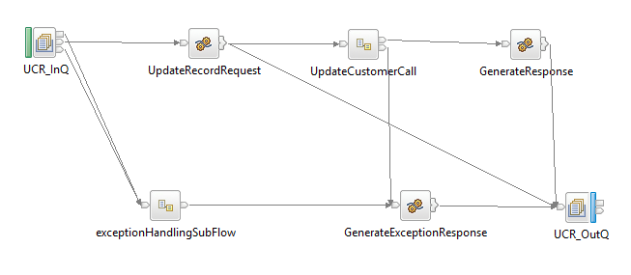

### Create Prospect Customer Process Diagram

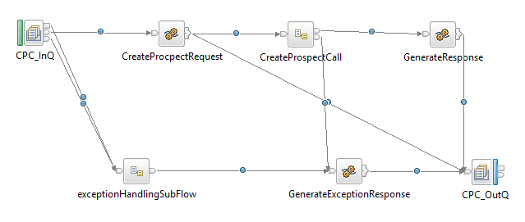

### Process Flow Steps

|  |  |
| --- | --- |
| **S. No** | **Activities** |
| 1. | ESB receives the request from the channel using the HTTP Router Application based on procesingcode & channelName the message will be routed to the Business Application (AccountOpeningRouterFlow) using Business Queue (ACC_MB_SB_HTTP_REQ)  i.e Request from channel. |
| 2 | Once Account Opening Router gets the message, ESB differentiate one request from other based on serviceCall tag. Account Opening Application has 7 different modules. For each module we are using a different queue which will be selected based on serviceCall value.The queue names are declared as UPD values and are follows below:   1. KYC_SB_REQ (knowYourCustomer) 2. SHC_SB_REQ (searchHITsOnCustomer) 3. CCP_SB_REQ (createCustomerProfile) 4. OCA_SB_REQ (openCustomerAccount) 5. UCR_SB_REQ (updateCustomerRecord) 6. CPC_SB_REQ (createProspectCustomer) |
| 3 | Initial request and response will be logged in the RAW_LOG_SB_REQ and is insert in Database (RAW_AUDIT_LOGGING). |
| 4 | ESB routes the request message to the selected queue as per the service call. |
| 5 | After logging of request ESB checks the values of the tag named “serviceCall”, The possible values are KYC, SHC, CCP, OCA, UCR and CPC. |
| 6 | If the values of serviceCall tag is other than mentioned above then, ESB frames a response to Channel saying “unknown Request”. |
| 7 | If the value is “KYC” then the request will be routed to “KYC_SB_REQ” queue for KYC process. ESB frames a Request to check whether customer record exists in DWH, If customer doesn’t exists in DWH then ESB frames a failure response to channel. DWH Response and Application response in JSON Format will be logged in RAW_LOG_SB_REQ and insert in Data Base (RAW_AUDIT_LOGGING). |
| 8 | If the value is “SHC” then the request will be routed to “SHC_SB_REQ” queue to search HITs (credit rating) on customer. ESB frames a request to search credit ratings on customer to FCB. The response from FCB will be enriched to send to channel.FCB Response and Application response in JSON Format will be logged in RAW_LOG_SB_REQ and insert in Data Base (RAW_AUDIT_LOGGING). |
| 9 | If the value is “ICE” then the request will be routed to “ICE_SB_REQ” queue to check whether customer exists in core banking system (T24) or not. ESB frames a request to T24 to check whether the customer exists in T24. The response from T24 will be enriched to send to channel. T24 Response and Application response in JSON Format will be logged in RAW_LOG_SB_REQ and insert in Data Base (RAW_AUDIT_LOGGING). |
| 10 | If the value is “CCP” then the request will be routed to “CCP_SB_REQ” queue to create customer profile in core banking system (T24). ESB frames a request to T24 to create customer profile. The response from T24 will be enriched to send to channel. T24 Response and Application response in JSON Format will be logged in RAW_LOG_SB_REQ and insert in Data Base (RAW_AUDIT_LOGGING). |
| 11 | If the value is “OCA” then the request will be routed to “OCA_SB_REQ” queue to create customer account in core banking system (T24). ESB frames a request to T24 to create customer account. The response from T24 will be enriched to send to channel. T24 Response and Application response in JSON Format will be logged in RAW_LOG_SB_REQ and insert in Data Base (RAW_AUDIT_LOGGING). |
| 12 | If the value is “UCR” then the request will be routed to “UCR_SB_REQ” queue to update customer profile in DWH. ESB frames a request to DWH to update customer profile. The response from DWH will be enriched to send to channel. DWH Response and Application response in JSON Format will be logged in RAW_LOG_SB_REQ and insert in Data Base (RAW_AUDIT_LOGGING). |
| 13 | If the value is “CPC” then the request will be routed to “CPC_SB_REQ” queue to update customer profile in T24. ESB frames a request to T24 to create prospect customer profile in core banking system. Channel will send this request when there is bad credit rating found on customer. The response from T24 will be enriched to send to channel. T24 Response and Application response in JSON Format will be logged in RAW_LOG_SB_REQ and insert in Data Base (RAW_AUDIT_LOGGING). |
| 14 | On Unsuccessful calls of T24/DWH/FCB Request and Response will be placed in the ERROR_LOG_SB_REQ to log the request in Database (ERR_AUDIT_LOGGING). |

## Retry Process workflow

### HTTP Process Flow Diagram

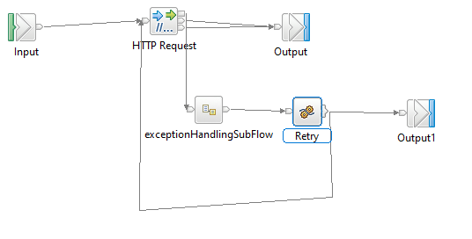

**Figure: 3 HTTP Retry for Account Opening**

### Process Flow steps

|  |  |
| --- | --- |
| **S. No** | **Activities** |
| 1 | HTTP Retry call is used to call the backend service for multiple times |
| 2 | On Successful call of backend service, response will be generated and send back to Business Application For further process |
| 3 | On Unsuccessful call of backend service it Retry for 3 times and sends error message to Business Application for further Process |

## Raw_Audit Process Flow:

### Process Flow Diagram:

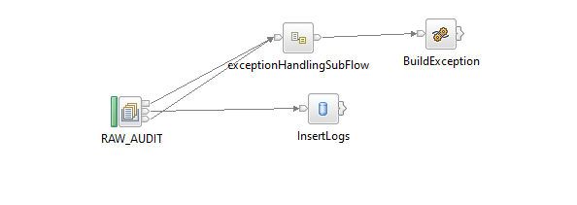

**Figure: 4 Raw_Audit_Logging Flow**

### Process Flow Steps:

|  |  |
| --- | --- |
| **S. No** | **Activities** |
|  | The RAW_AUDIT locks the input Request and Response |
|  | After the query is executed the record is inserted into the Database. |
|  | Final Response is inserted into the Database and then Response is logged into the RAW_LOG_SB_REQ. |

## HTTP Router Process Flow

### Incoming Router Process Flow Diagram:

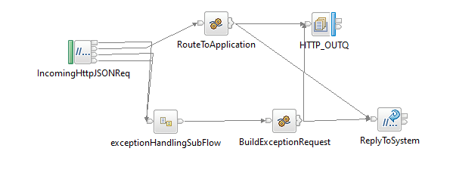

**Figure: 5 Incoming Router Flow**

### Process Flow Steps:

|  |  |
| --- | --- |
| **S. No** | IIB receives the request from channel. |
|  | ESB receives the request from channel. |
|  | Request channel is the http request accepts the request from the channel |
|  | The request message is placed in the RAW_LOG_SB_REQ to log the request in Database(RAW_AUDIT_LOGGING) |
|  | According to the Channel Request message fields such as channel and processing code it picks the queue name of the business flow from STWB_ESB_TRAN_DETAILS table and propagates it to the business flow. |
|  | It validates the processingCode, Channel and domain of input from STWB_ESB_TRAN_DETAILS if it fails to validate the error response is logged in the logs and in Data Base (ERROR_AUDIT_LOG). |
|  | After the validation Request message is passed through ESB. If the queue name presents in MQ manager the ESB business flow triggers otherwise the error response is sent to the front end as Unable to open queue. |
|  | If it is success or failure response will store them in RAW_AUDIT_LOG table or ERROR_AUDIT_LOG and logging into log file. |
|  | The request from channel is sent to ESB Account Opening Router Flow |

### STEWARDBANK ESB TRANSACTION DETAILS

**Table Name: STWB_ESB_TRAN_DETAILS**

|  |  |  |  |  |  |  |
| --- | --- | --- | --- | --- | --- | --- |
| **Item #** | **DB Field Name** | **Field Description** | **Data Type** | **Length** | **Mandatory(Yes/No)** | **Comments** |
| 1 | PROC_CODE | Processing Code | Varchar | 20 | Y | From input request |
| 2 | TCP_REQ_QNAME | TCPIP Request Queue | Varchar | 20 | N | This Request Queue Name field is used for ISO Related Application |
| 3 | TCP_RES_QNAME | TCPIP Response Queue | Varchar | 20 | N | This Response Queue Name field is used for ISO Related Application |
| 4 | HTTP_REQ_QNAME | HTTP Request Queue | Varchar | 20 | Y | This Request Queue Name field is used for REST Related Application |
| 5 | HTTP_RES_QNAME | HTTP Response Queue | Varchar | 20 | Y | This Response Queue Name field is used for REST Related Application |
| 6 | CHANNEL | Channel | Varchar | 20 | Y | Channel Name |
| 7 | MSGDOMAIN | Message Domain | Varchar | 20 | Y | Request Message Format |
| 8 | APPLICATION_NAME | Name of the application | Varchar | 50 | Y | Name of the application that is create for this particular interface and committed in GIT. |
| 9 | SERVICE_NAME | Name of the service | Varchar | 50 | Y | Name of the service to identify in the Database Table. |

### Outgoing Router Process Flow Diagram

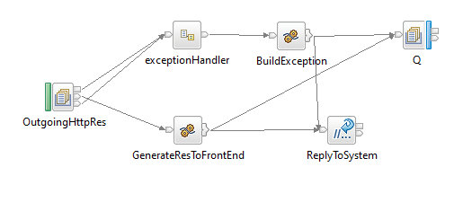

**Figure: 6 Outgoing Router Flow**

### Process Flow Steps:

|  |  |
| --- | --- |
| **S. No** | **Activities** |
|  | The OutgoingHttpRes brings the Channel Response |
|  | Channel Response will be logged in RAW_LOG_SB_REQ and insert in Data Base. |
|  | Finally Channel Response will be send to the Front End. |

## Error_Audit Process Flow

### Process Flow Diagram:

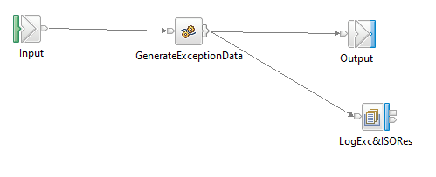

**Figure: 7 Exception Subflow**

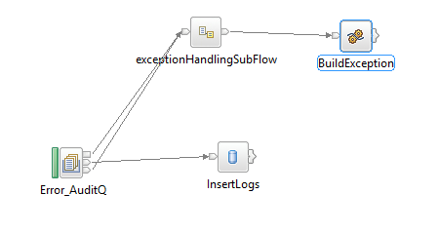

**Figure: 8 Error_Audit_Logging Flow**

### Process Flow Steps:

|  |  |
| --- | --- |
| **S. No** | **Activities** |
|  | The ERROR_AUDIT_Q locks the input Request. |
|  | After the query is executed the record is inserted into the Database. |
|  | Final Response is inserted into the Database and then Response is logged into the ERR_LOG_SB_REQ. |

# Interface Definitions

## Request Message Definition

### Channel Request Message Structure /Schema

**Request Type:** HTTP

**Request Format:** JSON

**Request URL:** <http://IPAddress:Port/v1/stewardBank/>

### Channel Request Message Details

KYC Request:

|  |  |  |  |  |
| --- | --- | --- | --- | --- |
| **Item #** | **Tag Name/ Field Name** | **Data Type** | **Mandatory(Yes/No)** | **Comments** |
| 1 | channel | String | Y | Channel Name |
| 2 | processingCode | String | Y | Processing Code |
| 3 | serviceCall | String | Y | Type of service call |
| 4 | national_Id | String | Y | National id of the customer |

Search HITs on Customer Request:

|  |  |  |  |  |
| --- | --- | --- | --- | --- |
| **Item #** | **Tag Name/ Field Name** | **Data Type** | **Mandatory(Yes/No)** | **Comments** |
| 1 | channel | String | Y | Channel Name |
| 2 | processingCode | String | Y | Processing Code |
| 3 | serviceCall | String | Y | Type of service call |
| 4 | dob | String | Y | Date of birth of the customer |
| 5 | names | String | Y | Name of the customer |
| 6 | surname | String | Y | surname of the customer |
| 7 | national_id | String | Y | national Id of the customer |
| 8 | gender | String | Y | Gender of the customer |
| 9 | search_purpose | String | Y | Search purpose |
| 10 | email | String | Y | Email id of the customer |
| 11 | password | String | Y | Password |
| 12 | drivers_license | String | Y | Driving license of the customer |
| 13 | passport | String | O | Passport number of the customer |
| 14 | married | String | O | Marital status of the customer |
| 15 | nationality | String | Y | Nationality of the customer |
| 16 | streetno | String | Y | Street number where customer resides |
| 17 | streetname | String | Y | Street name where customer resides |
| 18 | building | String | O | Building number |
| 19 | suburb | String | O |  |
| 20 | pbag | String | O |  |
| 21 | city | String | Y | City where customer resides |
| 22 | telephone | String | O | Telephone number of the customer |
| 23 | mobile | String | Y | Mobile number of the customer |
| 24 | ind_email | String | O | Industry mail id of the customer |
| 25 | property_density | String | Y | Property density of the customer |
| 26 | property_status | String | Y | Property status |
| 27 | occupation_class | String | Y | Occupation class |
| 28 | employer | String | Y | Employer of the customer |
| 29 | employer_industry | String | Y | Industry to which customers profession belongs. |
| 30 | salary_band | String | Y | Salary band of the customer |
| 31 | loan_purpose | String | Y | Purpose of taking loan |
| 32 | loan_amount | String | Y | Amount that has taken as loan. |

IsCustomerExists Request:

|  |  |  |  |  |
| --- | --- | --- | --- | --- |
| **Item #** | **Tag Name/ Field Name** | **Data Type** | **Mandatory(Yes/No)** | **Comments** |
| 1 | channel | String | Y | Channel Name |
| 2 | processingCode | String | Y | Processing Code |
| 3 | serviceCall | String | Y | Type of service call |
| 4 | identificationDocNo | String | Y | Identification Document number of the customer |
| 5 | mobileNumber | String | Y | Mobile number of the customer |
| 6 | dataOfBirth | String | Y | Date of birth of the customer |

CreateCustomerProfile Request:

|  |  |  |  |  |
| --- | --- | --- | --- | --- |
| **Item #** | **Tag Name/ Field Name** | **Data Type** | **Mandatory(Yes/No)** | **Comments** |
| 1 | channel | String | Y | Channel Name |
| 2 | processingCode | String | Y | Processing Code |
| 3 | serviceCall | String | Y | Type of service call |
| 4 | customerMnemonic | String | Y | Customer Mnemonic of the customer |
| 5 | displayName | String | Y | Name of the customer to display to the frontend. |
| 6 | customerName | String | Y | Name of the customer |
| 7 | phoneNumber | String | Y | Phone number of the customer |
| 8 | smsNumber | String | Y | Sms number of the customer |
| 9 | email | String | Y | Email Id of the customer |
| 10 | dateOfBirth | String | Y | Date of birth of the customer |
| 11 | gender | String | Y | Gender of the customer |
| 12 | maritalstatus | String | Y | Marital status |
| 13 | street | String | Y | Street where customer resides |
| 14 | address | String | Y | Complete address of the customer |
| 15 | addressCity | String | Y | City where customer resides |
| 16 | legalId | String | Y | Legal Id of the document that customer provides |
| 17 | legalDocumentName | String | Y | Legal Document name |
| 18 | title | String | Y | Title |
| 19 | lastName | String | Y | Last name of the customer |
| 20 | givenName | String | Y | Given name |
| 21 | issueDate | String | Y | Issue date |

OpenCustomerAccount Request:

|  |  |  |  |  |
| --- | --- | --- | --- | --- |
| **Item #** | **Tag Name/ Field Name** | **Data Type** | **Mandatory(Yes/No)** | **Comments** |
| 1 | channel | String | Y | Channel Name |
| 2 | processingCode | String | Y | Processing Code |
| 3 | serviceCall | String | Y | Type of service call |
| 4 | customerId | String | Y | Customer id of the customer |
| 5 | productId | String | Y | Product id of the product which is being created for the customer |
| 6 | currencyId | String | Y | Currency id |
| 7 | activityId | String | Y | Activity id |

UpdateCustomerRecord Request:

|  |  |  |  |  |
| --- | --- | --- | --- | --- |
| **Item #** | **Tag Name/ Field Name** | **Data Type** | **Mandatory(Yes/No)** | **Comments** |
| 1 | channel | String | Y | Channel Name |
| 2 | processingCode | String | Y | Processing Code |
| 3 | serviceCall | String | Y | Type of service call |
| 4 | nationalId | String | Y | National id of the customer |
| 5 | msisdn | String | Y | msisdn of the customer |
| 11 | firstname | String | Y | First name of the customer |
| 12 | lastname | String | Y | Last name of the customer |
| 13 | datOfBirth | String | Y | Date of birth of the customer |
| 14 | dateCreated | String | Y | Creation date |
| 15 | accountNbr | String | Y | Account number of the customer |
| 16 | mnemonic | String | Y | Mnemonic created by the customer |
|  | fullName |  |  | Full name of the customer |
| 17 | gender | String | Y | Gender |
| 18 | title | String | Y | title |
| 19 | status | String | Y | Status |
| 20 | mobileNumber | String | Y | Mobile number of the customer |
| 21 | address | String | Y | Address of the customer |
| 22 | city | String | Y | City where customer resides |
| 23 | sector | String | O | Sector |
| 24 | industry | String | Y | Industry to which customers profession belongs |
| 25 | nationality | String | Y | Nationality of the customer |
| 26 | residence | String | Y | Residence |
| 27 | customerName | String | O | Name of the customer |
| 28 | loanProfiles | String | O | Loan profile of the customer |

CreateProspectCustomer Request:

|  |  |  |  |  |
| --- | --- | --- | --- | --- |
| **Item #** | **Tag Name/ Field Name** | **Data Type** | **Mandatory(Yes/No)** | **Comments** |
| 1 | channel | String | Y | Channel Name |
| 2 | processingCode | String | Y | Processing Code |
| 3 | serviceCall | String | Y | Type of service call |
| 4 | customerName | String | Y | Identification Document number of the customer |
| 5 | street | String | Y | Mobile number of the customer |
| 6 | address | String | Y | Date of birth of the customer |
| 7 | townCountry | String | Y | City where customer resides |
| 8 | country | String | Y | Country to which customer belongs |
| 9 | phoneNumber | String | Y | Phone number of the customer |
| 10 | emailAddress | String | Y | Email Id of the customer |
| 11 | gender | String | Y | gender |
| 12 | dateOfBirth | String | Y | Date of birth of the customer |
| 13 | identityDoc | String | Y | Name of the identification document |
| 14 | identificationDocNo | String | Y | Identification Document number of the customer |

### Channel Sample Source Messages

1. knowYourCustomer

Request:

{

    "KnowYourCustomer": {

        "header": {

            "channel": "MobileBanking",

            "processingCode": "292000",

            "serviceCall": "KYC"

        },

        "body": {

            "national_id":"020100509L28"

        }

    }

}

1. searchHITsonCustomer

Request:

{

    "searchHITsOnCustomer": {

        "header": {

            "channel": "MobileBanking",

            "processingCode": "292000",

            "serviceCall": "SHC"

        },

        "body": {

            "dob": "03-03-1986",

            "names": "Mohsin",

            "surname": "Ali",

            "national_id": "12345678A00",

            "gender": "M",

            "search_purpose": "1",

            "email": "padma.maggari@eidiko.com",

            "password": "tawa@steward",

            "drivers_licence": "drv",

            "passport": "pp",

            "married": "M",

            "nationality": "3",

            "streetno": "24",

            "streetname": "harvey brown",

            "building": "fcb mansion",

            "suburb": "milton park",

            "pbag": "p.o. highlands",

            "city": "harare",

            "telephone": "794367-9",

            "mobile": "0772495573",

            "ind_email": "padma.maggari@eidiko.com",

            "property_density": "1",

            "property_status": "2",

            "occupation_class": "1",

            "employer": "fcb",

            "employer_industry": "6",

            "salary_band": "3",

            "loan_purpose": "3",

            "loan_amount": "334.45"

        }

    }

}

1. isCustomerExists

Request:

{

    "isCustomerExists": {

        "header": {

            "channel": "MobileBanking",

            "processingCode": "292000",

            "serviceCall": "ICE"

        },

        "body": {

            "identificationDocNo": "DL234567",

"mobileNumber": "0777262722",

            "dateOfBirth": "19790101"

        }

    }

}

1. createCustomerProfile

Request:

{

    "createCustomerProfile": {

        "header": {

            "channel": "MobileBanking",

            "processingCode": "292000",

            "serviceCall": "CCP"

        },

        "body": {

            "customerMnemonic": "MUSA01",

            "displayName": "musa",

            "customerName": "moscow",

            "phoneNumber": "0124567890",

            "smsNumber": "0750982341",

            "email": "name@gmail.com",

            "dateOfBirth": "19880412",

            "gender": "MALE",

            "maritalstatus": "SINGLE",

            "street": "65 ZONE12",

            "address": "chego street",

            "addressCity": "Midrand",

            "legalId": "880412",

            "legalDocumentName": "DRIVING.LICENSE",

            "title": "",

            "lastName": "",

            "givenName": "",

            "issueDate": ""

        }

    }

}

1. updateCustomerRecord

Request:

{

    "updateCustomerRecord": {

        "header": {

            "channel": "MobileBanking",

            "processingCode": "292000",

            "serviceCall": "UCR"

        },

        "body": {

            "nationalId": null,

            "msisdn": null,

            "firstName": null,

            "lastName": null,

            "dateOfBirth": null,

            "dateCreated": null,

            "accountNbr": null,

            "mnemonic": null,

            "fullName": null,

            "gender": null,

            "title": null,

            "status": null,

            "mobileNumber": null,

            "address": null,

            "city": null,

            "sector": null,

            "industry": null,

            "nationality": null,

            "residence": null,

            "customerName": null,

            "loanProfiles": null

        }

    }

}

1. openCustomerAccount

Request:

{

    "openCustomerAccount": {

        "header": {

            "channel": "MobileBanking",

            "processingCode": "292000",

            "serviceCall": "OCA"

        },

        "body": {

            "customerId": "100305",

            "productId": "STW.PERSONAL.CURRENT",

            "currencyId": "ZWL",

            "activityId": "ACCOUNTS-NEW-ARR.CHANNEL"

        }

    }

}

1. createProspectCustomer

Request:

{

    "createProspectCustomer": {

        "header": {

            "channel": "MobileBanking",

            "processingCode": "292000",

            "serviceCall": "CPC"

        },

        "body": {

            "customerName": "musa",

            "street": "65 ZONE12",

            "address": "chego street",

            "townCountry": "Midrand",

            "country": "ZW",

            "phoneNumber": "0124567890",

            "emailAddress": "name@gmail.com",

            "gender": "MALE",

            "dateOfBirth": "19880412",

            "identityDoc": "DRIVING.LICENSE",

            "identificationDocNo": "123456789"

        }

    }

}

}

### T24 Request Message Structure /Schema

**Request Type:** HTTP

**Request Format:** JSON

**Request URL:**http://IPAddress:Port/stwbc/api/v1.0.0/stwb/enquiries/currencies/details

### T24 Response Message Details

|  |  |  |  |  |
| --- | --- | --- | --- | --- |
| **Item #** | **Tag Name/ Field Name** | **Data Type** | **Mandatory(Yes/No)** | **Comments** |
| 1 | customerId | String | Y | Customer id of the customer |
| 2 | productId | String | Y | Id of the product selected by customer |
| 3 | currencyId | String | Y | Currency Id of the country that customer belongs to. |
| 3 | activityId | String | Y | Activity id. |

### T24 Sample Source Messages

|  |
| --- |
| {     "header":{            "override":{           "overrideDetails":[           ]        }     },     "body":{        "customerIds":[           {              "customerId":"100121"           }        ],        "properties":[        ],        "productId":"STW.PERSONAL.CURRENT",        "currencyId":"ZWL",        "activityId":"ACCOUNTS-NEW-ARR.CHANNEL"     }  } |

## Response Message Definition

### Channel Response Message Structure/Schema

**Response Type:** JSON

### Channel Response Message Details

KnowYourCustomer Response:

|  |  |  |  |  |
| --- | --- | --- | --- | --- |
| **Item #** | **Tag Name/Field Name** | **Data Type** | **Mandatory(Yes/No)** | **Comments** |
| 1 | channel | String | Y | Channel Name |
| 2 | processingCode | String | Y | Processing code of the interface |
| 3 | serviceCall | String | Y | Type of service call |
| 4 | status | String | Y | Status of the response |
| 5 | nationalId | String | Y | National Id of the customer |
| 6 | msisdn | String | Y | msisdn of the customer |
| 7 | firstName |  |  | First Name of the customer |
| 8 | lastName | String | Y | Last name of the customer |
| 9 | dateOfBirth | String | Y | Date of birth |
| 10 | dateCreated | String | Y | Date of profile creation |
| 11 | accountNbr | String | Y | Address of the customer |
| 12 | mnemonic | String | Y | Mnemonic |
| 13 | fullName | String | Y | Full name of the customer |
| 14 | gender | String | Y | Gender |
| 15 | title | String | Y | Title |
| 16 | status | String | Y | Status |
| 17 | mobileNumber | String | Y | Mobile number of the customer |
| 18 | address | String | Y | Address |
| 19 | city | String | Y | City |
| 20 | sector | String | Y | Sector |
| 21 | industry | String | Y | Industry to which customers profession belongs |
| 22 | nationality | String | Y | Nationality of the customer |
| 23 | residence | String | Y | Residence |
| 24 | customerName | String | Y | Customer name |
| 25 | id | String | Y | Loan id |
| 26 | loanPackageName | String | Y | Loan package name |
| 27 | loanAmount | String | Y | Loan Amount taken |
| 28 | dateCreated | String | Y | Loan created date |
| 29 | startDate | String | Y | Loan start date |
| 30 | expiryDate | String | Y | Expiry date |
| 31 | nationalIdNumber | String | Y | National Id number |
| 32 | schedule | String | Y | Schedule |
| 33 | accountNumber | String | Y | Account number of the customer |
| 34 | mobileNumber | String | Y | Mobile number |
| 35 | balanceOutstanding | String | Y | Balance outstanding |
| 36 | loanStatus | String | Y | Loan status |
| 37 | customerProfileId | String | Y | Customer Profile Id |
| 38 | penalty | String | Y | Penalty up on loan |
| 39 | lastAutoreplayFailureDescription | String | Y | Failure description |
| 40 | lastPenaltiesChargedDate | String | Y | Date of last penalty charged |
| 41 | lastTryAutorepayDate | String | Y | Date od last auto repay |
| 42 | numPenaltiesCharged | String | Y | Numeric penalty charged |
| 43 | numTryAutorepay | String | Y | Auto repay try |
| 44 | channel | String | Y | Loan channel |

IsCustomerExists Response:

|  |  |  |  |  |
| --- | --- | --- | --- | --- |
| **Item #** | **Tag Name/ Field Name** | **Data Type** | **Mandatory(Yes/No)** | **Comments** |
| 1 | channel | String | Y | Channel Name |
| 2 | processingCode | String | Y | Processing code of the interface |
| 3 | serviceCall | String | Y | Type of service call |
| 4 | transactionStatus | String | Y | Transaction status |
| 5 | T24_time | String | Y | Time for T24 |
| 6 | parse_time | String | Y | Time of parsing. |
| 7 | page_start | String | Y | Starting page. |
| 8 | page_token | String | Y | Token number. |
| 9 | total_size | String | Y | Total size of response. |
| 10 | page_size | String | Y | Size of the response pages. |
| 11 | customerMnemonic | String | Y | Customer mnemonic of the customer |
| 12 | lastName | String | Y | Last name of the customer |
| 13 | country | String | Y | Country |
| 14 | street | String | Y | Street where customer resides |
| 15 | addressDetail | String | Y | Address details |
| 16 | addressCity | String | Y | City |
| 17 | targetName | String | Y | Target Name |
| 18 | gender | String | Y | Gender |
| 19 | employerName | String | Y | Employer Name |
| 20 | title | String | Y | Title |
| 21 | customerStatus | String | Y | Customer status |
| 22 | customerSalary | String | Y | Customer salary |
| 23 | industryId | String | Y | Industry Id |
| 24 | accountOfficerId | String | Y | Account Officer Id |
| 25 | occupation | String | Y | Occupation of the customer |
| 26 | customerId | String | Y | Customer Id |
| 27 | statusName | String | Y | Status Name |
| 28 | accountOfficerName | String | Y | Account Officer Name |
| 29 | legalIssueDate | String | Y | Legal Issue Date |
| 30 | legalDocumentName | String | Y | Legal Document Name |
| 31 | legalHolderName | String | Y | Legal Holder Name |
| 32 | industryName | String | Y | Industry Name |
| 33 | sectorId | String | Y | Sector Id |
| 34 | nationalityId | String | Y | Nationality Id |
| 35 | languageId | String | Y | Language Id |
| 36 | dateOfBirth | String | Y | Date of birth of the customer |
| 37 | sectorName | String | Y | Sector Name |
| 38 | email | String | Y | Email Id of the customer |
| 39 | phoneNumber | String | Y | Phone Number of the customer |
| 40 | customerName | String | Y | Customer Name |
| 41 | residenceId | String | Y | Residence Id |
| 42 | versionNumber | String | Y | Version Number |
| 43 | target | String | Y | Target |
| 44 | firstName | String | Y | First Name of the customer |
| 45 | maritalStatus | String | Y | Marital status of the customer |

CreateCustomerProfile Response:

|  |  |  |  |  |
| --- | --- | --- | --- | --- |
| **Item #** | **Tag Name/ Field Name** | **Data Type** | **Mandatory(Yes/No)** | **Comments** |
| 1 | channel | String | Y | Channel Name |
| 2 | pocessingCode | String | Y | Processing code of the interface |
| 3 | serviceCall | String | Y | Type of service call |
| 4 | transactionStatus | String | Y | Transaction status |
| 5 | T24_time | String | Y | Time for T24 |
| 6 | Parse_time | String | Y | Time of Parsing |
| 7 | responseParse_time | String | Y | Response parsing time. |
| 8 | requestParse_time | String | Y | Request parsing time. |
| 9 | versionNumber | String | Y | Version number |
| 10 | id | String | Y | Customer id |
| 11 | status | String | Y | Status |
| 12 | customerMnemonic | String | Y | Customer Mnemonic of the customer |
| 13 | lastName | String | Y | Last name of the customer |
| 14 | address | String | Y | Address of the customer |
| 15 | gender | String | Y | Gender |
| 16 | street | String | Y | Street |
| 17 | customerName | String | Y | Customer Name |
| 18 | language | String | Y | Language |
| 19 | title | String | Y | Title |
| 20 | PhoneNumber | String | Y | Phone number of the customer |
| 21 | smsNumber | String | Y | Sms Number |
| 22 | email | String | Y | Email Id of the customer |
| 23 | customerStatus | String | Y | Customer status |
| 24 | industryId | String | Y | Industry Id |
| 25 | accountOfficerId | String | Y | Account Officer Id |
| 26 | customerCompany | String | Y | Customer Company name |
| 27 | amlResult | String | Y | Aml Result |
| 28 | sectorId | String | Y | Sector Id |
| 29 | nationalityId | String | Y | Nationality Id of the customer |
| 30 | givenName | String | Y | Given name of the customer |
| 31 | addressCity | String | Y | Address city |
| 32 | displayName | String | Y | Display name |
| 33 | dateOfBirth | String | Y | Date of birth of the customer |
| 34 | amlCheck | String | Y | Aml check |
| 35 | residenceId | String | Y | Residence Id of the customer |
| 36 | target | String | Y | Target |
| 37 | maritalstatus | String | Y | Marital status |
| 38 | legalIssueDate | String | Y | Legal issue date |
| 39 | legalId | String | Y | Legal Id |
| 40 | legalDocumentName | String | Y | Legal document name |

Open Customer Account to Channel:

|  |  |  |  |  |
| --- | --- | --- | --- | --- |
| **Item #** | **Tag Name/ Field Name** | **Data Type** | **Mandatory(Yes/No)** | **Comments** |
| 1 | transactionStatus | String | Y | Transaction status |
| 2 | T24_time | String | Y | Time for T24 |
| 3 | Parse_time | String | Y | Time of Parsing |
| 4 | responseParse_time | String | Y | Response parsing time. |
| 5 | requestParse_time | String | Y | Request parsing time. |
| 6 | aaaId | String | Y | Unique Id in response |
| 7 | status | String | Y | Response status |
| 8 | channel | String | Y | Channel Name |
| 9 | pocessingCode | String | Y | Processing code of the interface |
| 10 | serviceCall | String | Y | Type of service call |
| 11 | arrangementId | String | Y | Arrangement Id |
| 12 | activityId | String | Y | Activity Id |
| 13 | productId | String | Y | Id of the product selected by the customer |
| 14 | customerId | String | Y | Customer id issued to customer |
| 15 | currencyId | String | Y | Currency Id |
| 16 | effectiveDate | String | Y | Date when account will be active |

CreateProspectCustomer Response:

|  |  |  |  |  |
| --- | --- | --- | --- | --- |
| **Item #** | **Tag Name/ Field Name** | **Data Type** | **Mandatory(Yes/No)** | **Comments** |
| 1 | transactionStatus | String | Y | Transaction status |
| 2 | T24_time | String | Y | Time for T24 |
| 3 | Parse_time | String | Y | Time of Parsing |
| 4 | responseParse_time | String | Y | Response parsing time. |
| 5 | requestParse_time | String | Y | Request parsing time. |
| 6 | versionNumber | String | Y | Version number |
| 7 | id | String | Y | Customer id |
| 8 | status | String | Y | Status |
| 9 | channel | String | Y | Channel Name |
| 10 | pocessingCode | String | Y | Processing code of the interface |
| 11 | serviceCall | String | Y | Type of service call |
| 12 | email | String | Y | Email Id of the customer |
| 13 | legalId | String | Y | Legal Id |
| 14 | legalDocumentName | String | Y | Legal document name |
| 15 | address | String | Y | Address of the customer |
| 16 | gender | String | Y | gender |
| 17 | street | String | Y | Street where customer lives |
| 18 | townCountry | String | Y | City name |
| 19 | customerName | String | Y | Customer name |
| 20 | dateOfBirth | String | Y | Date of birth of the customer |
| 21 | country | String | Y | Country name |
| 22 | phoneNumber | String | Y | Phone number of the customer |
| 23 | personEntity | String | Y | Person Entity |

### Channel Sample Response Messages

KnowYourCustomer Response:

{

    "KnowYourCustomer": {

        "header": {

            "channel": "MobileBanking",

            "processingCode": "292000",

            "serviceCall": "KYC",

"status": "SUCCESS"

        },

        "body": {

       "nationalId": "020100509L28",

        "msisdn": "263714938081",

        "firstName": "NAMBI ",

        "lastName": "MBEDZI",

        "dateOfBirth": "14/12/1992",

        "dateCreated": "22/11/2018",

        "accountNbr": "1011356369",

        "mnemonic": "NAMBI MBEDZI",

        "fullName": "NAMBI MBEDZI",

        "gender": null,

        "title": null,

        "status": null,

        "mobileNumber": "2.6378E+11",

        "address": null,

        "city": "Harare",

        "sector": null,

        "industry": null,

        "nationality": "716",

        "residence": null,

        "customerName": null,

        "loanProfiles": [

            {

                "id": "1",

                "loanPackageName": null,

                "loanAmount": "20",

                "dateCreated": "2018-08-21T18:51:34.000+00:00",

                "startDate": "2018-08-21T18:51:34.000+00:00",

                "expiryDate": "2018-09-20T18:51:34.000+00:00",

                "nationalIdNumber": "020100509L28",

                "schedule": null,

                "accountNumber": "1006477247",

                "mobileNumber": "263773390349",

                "balanceOutstanding": 0.0,

                "loanStatus": "PAID",

                "customerProfileId": 1,

                "loanPackageId": 1,

                "penalty": 0.0,

                "lastAutorepayFailureDescription": null,

                "lastPenaltiesChargedDate": null,

                "lastTryAutorepayDate": null,

                "numPenaltiesCharged": 0,

                "numTryAutorepay": 0,

                "channel": null

            }

        ]

    }

}

IsCustomerExists Response:

{

    "isCustomerExists": {

        "header": {

            "channel": "MobileBanking",

            "processingCode": "292000",

            "serviceCall": "ICE"

        "audit": {

            "T24_time": 332,

            "parse_time": 4

        },

        "page_start": 1,

        "page_token": "202008294903131546.02,99",

        "total_size": 1,

        "page_size": 99

    },

    "body": [

        {

            "customerMnemonic": "JGGABA",

            "lastName": "GABARINOCHEKA",

            "addresses": [

                {

                    "country": "ZIMBABWE",

                    "street": "17 MBADA STREET",

                    "addressDetails": [

                        {

                            "addressDetail": "MUFAKOSE"

                        }

                    ],

                    "addressCity": "HARARE"

                }

            ],

            "targetName": "Priv Std Client",

            "gender": "MALE",

            "employerName": "TECHMAHINDRA",

            "title": "MR",

            "customerStatus": "1",

            "customerSalary": 120000,

            "industryId": "1000",

            "accountOfficerId": "2000",

            "coccupation": "Banking Consultant",

            "customerId": "100121",

            "statusName": "Priv Std Client",

            "accountOfficerName": "Credit - Lending",

            "legalDoc": [

                {

                    "legalIssueDate": "2004-05-04",

                    "legalId": "DL234567",

                    "legalDocumentName": "DRIVING.LICENSE",

                    "legalHolderName": "JOHNSON GILBERT GABARINOCHEKA"

                }

            ],

            "industryName": "Private Person (Name)",

            "sectorId": "1000",

            "nationalityId": "ZW",

            "languageId": "English",

            "dateOfBirth": "1979-01-01",

            "sectorName": "***Individuals**",

            "contactDetails": [

                {

                    "emails": [

                        {

                            "email": "jgaba@gmail.com"

                        }

                    ],

                    "phoneNumbers": [

                        {

                            "phoneNumber": "0777262722"

                        }

                    ]

                }

            ],

            "customerName": "JOHNSON GILBERT GABARINOCHEKA",

            "residenceId": "Zimbabwe",

            "versionNumber": "7",

            "target": "1",

            "firstName": "JOHNSON GILBERT",

            "maritalStatus": "MARRIED"

        }

    ]

}

}

CreateCustomerProfile Response:

{

    "createCustomerProfile": {

        "header": {

            "channel": "MobileBanking",

            "processingCode": "292000",

            "serviceCall": "CCP",

        "transactionStatus": "Unapproved",

        "audit": {

            "T24_time": 259,

            "parse_time": 1,

            "responseParse_time": 1,

            "requestParse_time": 3,

            "versionNumber": "1"

        },

        "id": "100326",

        "status": "success"

    },

    "body": {

        "customerMnemonic": "MUSA01",

        "lastName": "JULES",

        "addresses": [

            {

                "address": "chego street"

            }

        ],

        "gender": "MALE",

        "streets": [

            {

                "street": "65 ZONE12"

            }

        ],

        "customerNames": [

            {

                "customerName": "moscow"

            }

        ],

        "language": 1,

        "title": "MR",

        "communicationDevices": [

            {

                "phoneNumber": "0124567890",

                "smsNumber": "0750982341",

                "email": "name@gmail.com"

            }

        ],

        "customerStatus": 6,

        "industryId": 1308,

        "accountOfficerId": 2900,

        "customerCompany": "ZW0010001",

        "amlResult": "NULL",

        "sectorId": 1011,

        "nationalityId": "ZW",

        "givenName": "Moscow",

        "addressCities": [

            {

                "addressCity": "Midrand"

            }

        ],

        "displayNames": [

            {

                "displayName": "musa"

            }

        ],

        "dateOfBirth": "1988-04-12",

        "amlCheck": "NULL",

        "residenceId": "ZW",

        "target": 999,

        "maritalstatus": "SINGLE",

        "legalDetails": [

            {

                "legalIssueDate": "2020-08-13",

                "legalId": "880412",

                "legalDocumentName": "DRIVING.LICENSE"

            }

        ]

    }

}

}

UpdateCustomerRecord Response:

{

    "updateCustomerRecord": {

        "header": {

            "channel": "MobileBanking",

            "processingCode": "292000",

            "serviceCall": "UCR"

        },

        "body": {

}

}

OpenCustomerAccount Response:

{

    "openCustomerAccount": {

        "header": {

        "transactionStatus": "Live",

        "audit": {

            "T24_time": 7723,

            "responseParse_time": 7,

            "requestParse_time": 5

        },

        "aaaId": "AAACT20226KDDZ3R0S",

        "status": "success",

"channel": "MobileBanking",

            "processingCode": "292000",

            "serviceCall": "OCA"

    },

    "body": {

        "arrangementActivity": {

            "arrangementId": "AA20226Q6J2D",

            "activityId": "ACCOUNTS-NEW-ARR.CHANNEL",

            "productId": "STW.PERSONAL.CURRENT",

            "customerIds": [

                {

                    "customerId": "100305"

                }

            ],

            "currencyId": "ZWL",

            "effectiveDate": "2020-08-13"

        }

    }

}

}

CreateProspectCustomer Response:

{

    "createProspectCustomer": {

        "header": {

        "transactionStatus": "Unapproved",

        "audit": {

            "T24_time": 198,

            "parse_time": 1,

            "responseParse_time": 1,

            "requestParse_time": 2,

            "versionNumber": "1"

        },

        "id": "11",

        "status": "success",

"channel": "MobileBanking",

            "processingCode": "292000",

            "serviceCall": "CPC"

    },

    "body": {

        "emails": [

            {

                "email": "name@gmail.com"

            }

        ],

        "prospectLegalDetails": [

            {

                "legalId": "123456789",

                "legalDocumentName": "DRIVING.LICENSE"

            }

        ],

        "addresses": [

            {

                "address": "chego street"

            }

        ],

        "gender": "MALE",

        "streets": [

            {

                "street": "65 ZONE12"

            }

        ],

        "townCountries": [

            {

                "townCountry": "Midrand"

            }

        ],

        "customerNames": [

            {

                "customerName": "musa"

            }

        ],

        "dateOfBirth": "1988-04-12",

        "countries": [

            {

                "country": "ZW"

            }

        ],

        "phoneNumbers": [

            {

                "phoneNumber": "0124567890"

            }

        ],

        "personEntity": "PERSON"

    }

}

### Channel Error Response Message

**Error Response:**

{

"AccountOpening": {

"header": {

"channel": "MobileBanking",

"processingCode": "292000",

"status": "FAILED",

"responseCode": "000"

},

"responseBody": {

"source": "ESB",

"applicationName": "module name where error occurred",

"applicationErrorCode": " Error code displays here ",

"message": " Error message displays here "

}

}

}

### Data Base Error Response Codes

001 = "Fatal Exception";

002 = "Recoverable Exception";

003 = "Configuration Exception";

004 = "Security Exception";

005 = "Parser Exception";

006 = "Conversion Exception";

007 = "Data Base Exception";

008 = "User Exception";

009 = "Cast Exception";

010 = "Message Exception";

011 = "SQL Exception";

012 = "Socket Exception";

013 = "Socket Timeout Exception";

014 = "Unknown Exception";

015 = "Failure";

# Queue Details

## Table for Queue Details

|  |  |  |  |
| --- | --- | --- | --- |
| **QM Objects** | **Script** | | |
| Queues | Name | Purpose | Script Combined |
| ACC_MB_SB_TCP_REQ | Receives the Messages from Channel via Router to ESB AccountOpeningRouter. | <Final Script Will be placed, after complete Unit Testing> |
| KYC_SB_REQ | Receives the Messages from Channel via AccountOpeningRouter to KnowYourCustomer module. |
| SHC_SB_REQ | Receives the Messages from Channel via AccountOpeningRouter to searchHITsOnCustomer module. |
| ICE_SB_REQ | Receives the Messages from Channel via AccountOpeningRouter to IsCustomerExists module. |
| CCP_SB_REQ | Receives the Messages from Channel via AccountOpeningRouter to CreateCustomerProfile module. |
| OCA_SB_REQ | Receives the Messages from Channel via AccountOpeningRouter to OpenCustomerAccount module. |
| UCR_SB_REQ | Receives the Messages from Channel via AccountOpeningRouter to UpdateCustomerAccount module. |
| CPC_SB_REQ | Receives the Messages from Channel via AccountOpeningRouter to CreateProspectCustomer module. |
| ALL_SB_TCP_RES | This is the Queue used to send to response back to the channel via router. |
| RAW_LOG_SB_REQ | This queue is used to DB Log the successful transactions into the database. |
|  | ERR_LOG_SB_REQ | This queue is used to DB Log the error/unsuccessful transactions into the database. |  |
|  | SB_EXCQ | The common flow ‘StewardBankExceptionHandling’ uses this queue to store the exception details. |  |
|  | EXC_Q | This queue is used to store the exceptions occurred in the flows. |  |

# Logging Mechanism

## Insert into RAW_AUDIT_TABLE

**Table Name: RAW_AUDIT_TABLE**

|  |  |  |  |  |  |  |
| --- | --- | --- | --- | --- | --- | --- |
| **Item #** | **DB Field Name** | **Field Description** | **Data Type** | **Length** | **Mandatory(Yes/No)** | **Comments** |
| 1 | MSGID | MessageID | Varchar | 100 | Y | From input request |
| 2 | LOGGING_TIME | Logging Time | TimeStamp | 6 | Y | Name |
| 3 | MESSAGE | Message(Request/Response) | Clob | - | Y | Request from channel |
| 4 | MESSAGETYPE | Type of Message(Request/Response) | Varchar | 100 | Y | Type of message either Request or Response |
| 5 | APPNAME | Application Name | Varchar | 100 | Y | Name of the Application |
| 6 | BROKER | Broker Name | Varchar | 100 | Y | Broker Name |
| 7 | TIME_LOCAL_TRANSACTION | Transaction Time | Varchar | 20 | Y | Time of the Transaction |
| 8 | DATE_LOCAL_TRANSACTION | Transaction Date | Varchar | 20 | Y | Date of the Transaction |
| 9 | RETRIEVAL_REFERENCE_N | Retrieval Reference Number | Varchar | 20 | Y |  |

## Insert into ERROR_AUDIT_TABLE

**Table Name: ERROR_AUDIT_TABLE**

|  |  |  |  |  |  |  |
| --- | --- | --- | --- | --- | --- | --- |
| **Item #** | **DB Field Name** | **Field Description** | **Data Type** | **Length** | **Mandatory(Yes/No)** | **Comments** |
| 1 | MSGID | MessageID | Varchar | 50 | Y | From input request |
| 2 | LOGGING_TIME | Application Name | Timestamp | 50 | Y | Time of the logging |
| 3 | MESSAGE | Message Type(Request/Response) | Clob | 50 | Y | Request of the Message |
| 4 | MESSAGETYPE | Message Type | Varchar | 50 | Y | Type of message either Request or Response |
| 5 | APPNAME | Application Name | Varchar | 4000 | Y | Name of the Application |
| 6 | BROKER | Broker Name | Varchar | - | Y | Name of the Broker |
| 7 | ERRORDESCRIPTION | Exception | Clob | 4000 | Y | Exception Information |
| 8 | TIME_LOCAL_TRANSACTION | Transaction Time | Varchar | 20 | Y | Time of the Transaction |
| 9 | DATE_LOCAL_TRANSACTION | Transaction Date | Varchar | 20 | Y | Date of the Transaction |
| 10 | RETRIEVAL_REFERENCE_NUMBER | Retrieval Reference Number | Varchar | 20 | Y | Retrieval Reference Number |
| 11 | BORKER_ERROR_CODE | Broker Error Code | Varchar |  | Y | Error code generate by Broker |
| 12 | USER_DEFINE_ERROR_CODE | User Defined Error Code | Varchar |  | Y | User Defined Code |

## File Based Logging

### Log4j

As part of auditing the request we have to use Log4j mechanism in the application to log the request in the file.

File Path: To be specified, while deploying the application